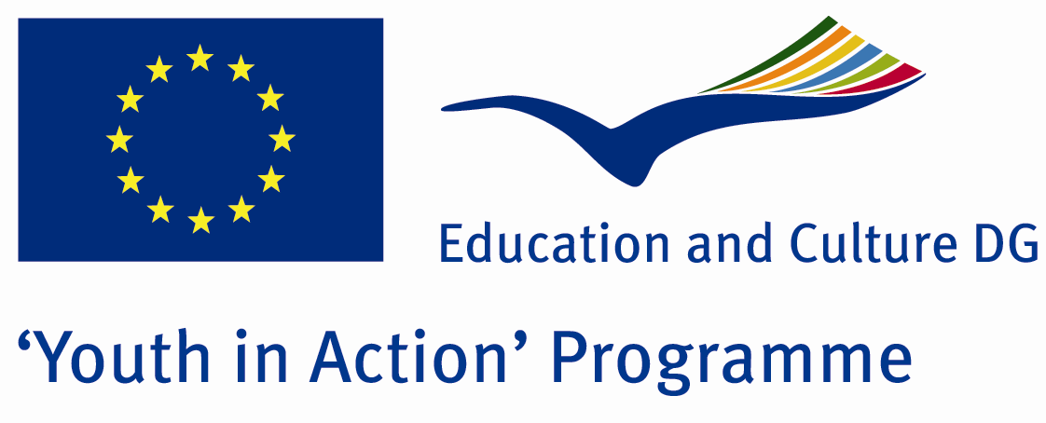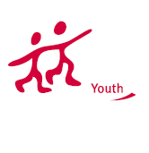

We’re Human We’re Wright



ACTION 1.1 – Youth Exchange

01 -08th July, 2011

Yalova, TURKEY

ACTION 1.1 Youth Exchange
01-08th July, 2011
Yalova, TURKEY

Please contact directly to;
adventurerpeacepigeons@gmail.com

Project Summary;

The human rights is the theme of our Project. Human rights and dignity of all people born equal and free in the defenses and human rights, independent individuals to make choices and provides the opportunity to develop skills. Human rights is sufficient to have a human being. But sometimes people forget and ignore the human rights. All countries had a war in their past. In that wars all innocent persons were dead but they deserved to live. Nowadays some people haven’t got tolerance to the other peoples idea and religion but all people are free their idea and their religion. These are their right and all people must be respectful. In our Project we will make conversation about human rights problems (right to live, right to work and unemployment, right to education, freedom about; idea, conscience and religion).We will make brainstorming and discussion in our convention. We are trying to find a solution all together. All participants will make a maquette tree with wood and carton , will show it in front of the place where we can stay and we can share it with citizens. We are making the Project in Yalova and stay there for a week. During the week we will become conscious about the human rights and joining time together. All participants have got more tolerance to other people when they are back their country.

Project Title; We’re Human We’re Right

Date and Venue ; 01-08th July, 2011 Yalova, Turkey .

Target Group ; Municipalities, City Councils and Non-Governmental organizations,
youth groups,culture and art groups,e.t.c

Participants ; 5 people from each country (over 18 -25 ). Totally 8 countries.

Conditions ; Accommodation, board and programme costs will be financed through European Commission Youth in Action Programme (Action 1.1). Travel costs will be reimbursed in 70% (APEX Tarrifs). Organizations from all 27 EU member countries plus Liechtenstein , Norway and Iceland are eligible to take part.

Working language: English

Organizer; Discovery And Adventure Group

How to apply: If you are interested, please send your Part III forms to
0090 216 483 21 67 by FAX please. (Fulfilled Part III which you can find in the attachment, of course signed and stamped) ..

Note: jpeg is not allowed..please send by fax…

Next step 2;
Original send via regular post to this address please:

Ertan DERİN
Öner İnşaat
Abdulhalik Renda Cd.
Parlar Sk. No:4 Pendik/İSTANBUL

If you have any questions you may contact with: adventurerpeacepigeons@gmail.com

Deadline for application; until 20th January 2011.

For Further information:
Contact Person
Ertan DERİN
Öner İnşaat
Abdulhalik Renda Cd.
Parlar Sk. No:4 Pendik/İSTANBUL

e-mail : adventurerpeacepigeons@gmail.com
Mobile : 0090 542 393 93 90
Fax : 0090 216 483 21 67

